The 2 Idiots Travel Blog
http://www.2idiotstravel.com

Ultimate Itinerary for a Cruise Day in Marseille, France
WHY THE 2 IDIOTS RECOMMEND MARSEILLE

While on a Mediterranean cruise, one of the port stops will be Marseille. We imagined a coastal French city to be romantically nautical, and it was exactly as we pictured: sailboats and ships, gorgeous waterfront views, and to-die-for seafood.

CREATING AN IDEAL ITINERARY

As a port stop, you’ll only have about six hours to enjoy Marseille, so our suggested itinerary is meant to give you the most out of quick tour. Many will suggest visiting Notre Dame -- Basilique Notre-Dame de la Garde -- the top-rated TripAdvisor suggestion. While it would be beautiful, it’s on top of a hill overlooking the city and will take most of your port stop to visit it – you won’t have a chance to see any other part of Marseille. Skip it, and follow our itinerary, below.

We also find that cruise excursions are often overpriced and crowded, as well as not very flexible on schedule, which is not a good thing when traveling with kids. We decided to disembark and explore Marseille on our own, and although we only had only a few hours to enjoy the town, we fell in love with its charm immediately!

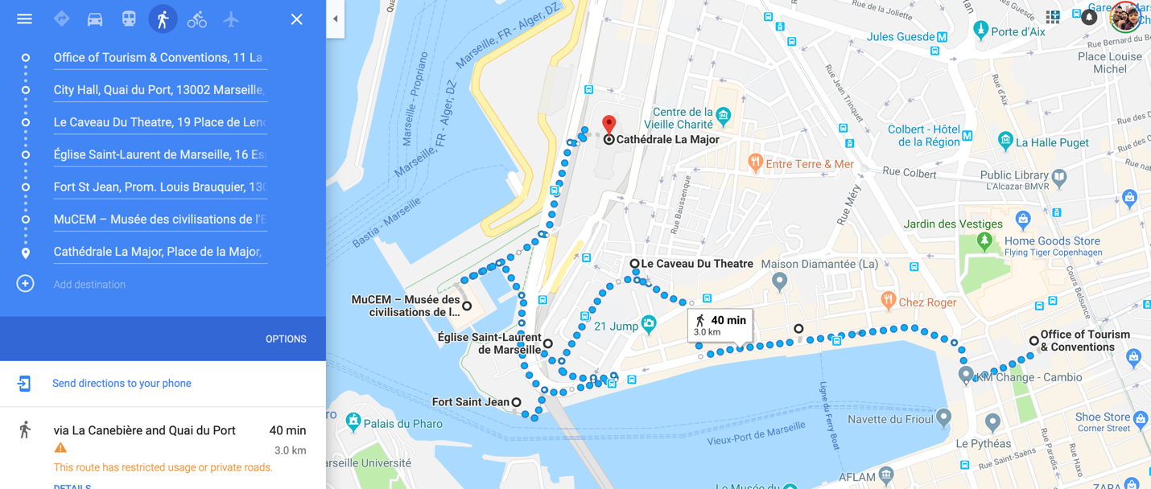
Vacation days | Itinerary | Estimated cost per person (only attractions)
Cruise Day | Walk around the Old Port  Enjoy lunch at Place de Lenche  Visit St. Laurent Church  Visit Fort Saint Jean  Relax at MuCem  Visit La Major Cathedral | You’ll just need about 10 Euro to get into the fortress and MuCem.

- When you get off the ship in port, grab a taxi and ask to be delivered to Old Port (Vieux-Port. There is a tourist office that makes the best place to be dropped off, as you can collect a map and more information on Marseille. From here, wander tiny streets filled with shops and walk down the pedestrian promenade of Canebiere. This area dates back centuries and is so popular a setting it has appeared in numerous movies, including the Count of Monte Cristo and Love Actually. Also, in Old Port is the Hotel de Ville, the city’s town hall that is quite picturesque. You’ll find the Phare de Sainte Marie lighthouse and a museum showcasing European and Mediterranean civilizations, although we just wandered about the area, roaming in and out of markets, allowing our son to run around, and taking Aarav on his very first carousel ride. (How many kids can say their first carousel was in Marseille?)

- Eat lunch in Quartier Le Panier, the oldest district of Marseille, where there are tons of quaint French restaurants. One of the main streets, with views of the sea, is the Rue du Petit Puits, and you can enjoy lunch in Place de Lenche, a square with amazing views of the Basilique Notre-Dame de la Garde. Of course, the specialty at this port city is seafood, and the restaurant we ate at was Le Caveau du Theatre which we loved.

- Tucked into the old quarter is the 12th century St. Laurent Church, constructed of pink limestone. It’s one of the few buildings to survive bombings in WWII. It’s worth a quick peek.

- From the church, cross the small bridge over to Fort Saint-Jean. Built in the 1600s to fortify the city from attackers from the sea, the fort provided a lot of open space for our son to run and play, and we spent an hour here. Be forewarned: there are a lot of stairs and we had to carry our son’s stroller up and down a lot, but he loved it.

- Another small bridge from the fort will connect you to the MuCem, which is in a newer area of Marseilles. MuCem is a museum dedicated to the Mediterranean and it overlooks the sea. We skipped the museum but enjoyed the area, where we saw people diving and doing tricks into the ocean, as well as live music and shops. This is a good stop for grabbing a delicious Marseille coffee and people watching.

- Before you leave Marseille, make your way to the other “major” cathedral in the city, Cathedrale de la Major. Parts of the church were constructed in the 12th century, with a new church added in the 1800s. It’s not Notre Dame, but a pretty church, nonetheless.
KID-FRIENDLY TIPS

- Although Marseille is filled with sunlight and the water sparkles a beautiful blue, it is also very windy. Be sure you have a windbreaker or a sweater; it can be chillier than you think.

- Marseille is very hilly and you’ll be doing a lot of walking up and down… and make sure you have a good travel stroller!

- If you have a picky child, the menus may be a bit limited especially if you are looking for seafood. Bring some snacks from the ship or carry a to-go meal prepared by the ship.

OTHER TIPS
- The port is about 10 to 15 minutes away from Marseille and cruise lines typically offer a shuttle into Old Town. They charge per person and have pre-set times. We found taxis readily available that cost less and let us travel on our schedule. Have the taxi drop you at the tourist information center, where you can find out what to see and do and pick up maps.

- Make sure you try seafood in Marseille. This is a fisherman’s town and the seafood is going to be so fresh it will melt in your mouth. (We loved Le Caveau du Theatre.) Marseille’s coffee is also delicious, enjoy a coffee, chocolate and definitely a glass of French wine on your visit.

- If you have more time in Marseille, definitely visit Basilique Notre-Dame de la Garde. This towering Catholic Church, built in the 18th century, overlooks the city and the sea and is the most visited site in Marseille.

